KIDNEY STONE DETECTION USING MATLAB

**Abstract:** Nowadays, kidney stone has become a major problem and if not detected at an early Stage, then it may cause complications and sometimes surgery is also needed to remove the stone. This study presents an ultrasound speckle suppression method to detect the stones in the human kidney. An initial image is first improved using image enhancement techniques, which are used to change the image’s intensities. Next, median filters smooth the picture and eliminate noise. Pre-processed images are segmented using a thresholding technique. The suggested approach locates stones using location coordinates. The suggested scheme has been assessed by different performance measuring parameters. Physicians are likely to benefit from the research in terms of clinical diagnosis and educational training. Based on 30 test cases, the proposed plan was correct 96%.

**Key Words**: Kidney stone detection, image processing, wavelet processing, ultrasound images, median filter, canny edge detection.

# INTRODUCTION

Kidney stone disease is one of the major life-threatening ailments persisting worldwide. Kidney stone, also known as a renal calculus is a solid piece of material which is formed in the kidneys from minerals in urine. Kidney stones typically leave the body in the urine stream, and a small stone may pass without causing symptoms. The stone diseases remain unnoticed in the initial stage, which in turn damages the kidney as they develop. Since kidney malfunctioning can be menacing, diagnosis of the problem in the initial stages is advisable.

Ultrasound image is one of the currently available methods with non-invasive low cost and widely used imaging techniques for analyzing kidney diseases Digital Image Processing means processing digital image by means of a digital computer. Digital image processing deals with manipulation of digital images through a digital computer. The input of that system is a digital image and the system process that image using efficient algorithms, and gives an image as an output [1]. Image processing mainly include the following steps:

1. Importing the image via image acquisition tools.
2. Analyzing and manipulating the image.
3. Output in which result can be altered image or a report which is based on analyzing that image.

# TYPES OF KIDNEY STONE DETECTION-

These may include:

1. **Blood testing**: Blood tests may reveal too much calcium or uric acid in your blood. Blood test results help monitor the health of your kidney.
2. **Urine testing**: The 24-hour urine collection test may show that you're excreting too many stone-forming minerals or too few stone-preventing substances.
3. **Imaging**: Imaging tests may show kidney stones in your urinary tract. Options range from simple abdominal X- rays, which can miss small kidney stones.
4. **Analysis of passed stones**: You may be asked to urinate through a strainer to catch stones that you pass. Lab analysis will reveal the makeup of your kidney stones.

# METHODOLOGY

Detection

Output stone

Wavelet processing

Image segmentation

Image pre- processing

Input image

Fig:1-Methodology

It is divided into 4 modules namely

1. Image pre-processing
2. Image segmentation
3. Wavelet processing
4. Detection by morphological analysis

# IMAGE PRE-PROCESSING:

# As the ultrasound consists of speckle noise and is of low contrast pre-processing needs to be done. Pre-processing involves Image restoration, Smoothing & sharpening, Contrast enhancement. Pre-processing is a common name for operations with images at the lowest level of abstraction both input and output are intensity images [2]. The means associated with preprocessing of Ultrasound image, which are as follows:

* 1. Image restoration
  2. Smoothing and sharpening
  3. Contrast enhancement

# IMAGE RESTORATION

Image restoration is intended to mitigate the debasement of the Ultrasound image. Corruption might be because of movement obscure, commotion, and camera mis focus. The principal motivation behind picture rebuilding is to decrease the corruptions that are caused during securing of Ultrasound examining [3].

# SMOOTHENING AND SHARPENING:

Smoothing and honing capacity utilize the pixels in a N x N neighborhood about every pixel to adjust an image. For both smoothing and honing channels the bigger the N x N neighborhood the more grounded the smoothing or honing impact. The entirety of the smoothing and honing channels can be utilized with layers, mix modes, darkness, and covers to build their helpfulness [4].

# CONTRAST ENHANCEMENT:

The goal of image enhancement is to slow down the deterioration of the ultrasound image that occurs during scanning acquisition. Noise, blurring, and camera misfocus can all cause degradation. The level set function is employed in this system to ensure proper orientation. It is under the image preprocessing step. The average intensity in the small neighborhood is f (m, n), and the median is ϑ (m, n), then the evolution between max, 0 (p) and min, 0 (p) [5].

Input image

Restoration

Smoothing and Sharpening

Contrast enhancement

Output

Fig:2- Preprocessing of kidney image

**2. IMAGE SEGMENTATION-**

In digital image processing and computer vision, image segmentation is the process of partitioning a digital image into multiple segments. Image segmentation is typically used to locate objects and boundaries (lines, curves, etc.) in images. More precisely, image segmentation is the process of assigning a label to every pixel in an image such that pixels with the same label share certain characteristics [6].

**3. WAVELET PROCESSING-**

Wavelet transforms are a mathematical means for performing signal analysis when signal frequency varies over time. Wavelets are commonly used in image processing to detect and filter white Gaussian noise, due to their high contrast of neighbouring pixel intensity values. Using these wavelets, a wavelet transformation is performed on the two-dimensional image. In this project, the segmented image from the input is made to undergo wavelet transform to get compressed image [7].

**4. DETECTION BY MORPHOLOGICAL ANALYSIS-**

Morphological procedures are used to process images based on their forms when organizing elements. It removes unnecessary information (pixels) from the outer part of the region of interest during processing. (MA) is a method for identifying, structing and investing the total set of possible relationship contained in a given image [8].

**5. PROCESSED IMAGE-**

Ultrasound image Pre-processing Segmentation

Wavelet processing Output

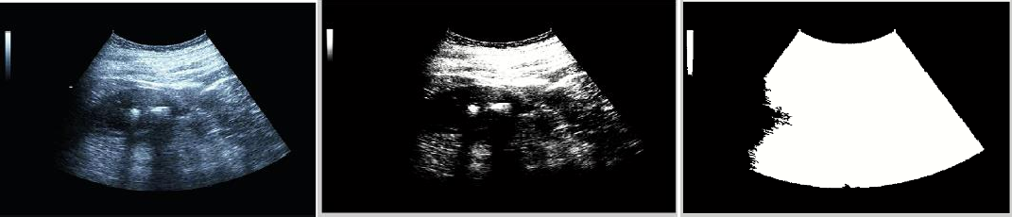

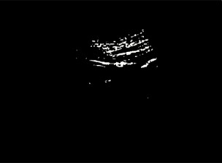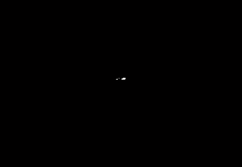

Fig:3- detection of stone

6. **Code-**

% import the ultrasound image of the kidney

[filename,pathname]=uigetfile('.','Pick a MATLAB code file');

filename=strcat(pathname,filename);

a=imread("C:\Users\mayur\OneDrive\Desktop\NOTES\5th Sem\C++\with stone.jpg");

imshow(a);

% convert the image RGB to GRAY

b=rgb2gray(a);

figure;

%histogram of the image

imshow(b);

impixelinfo;

%binarized the image

c=b>20;

figure;

imshow(c);

%fill the holes

d=imfill(c,'holes');

figure;

imshow(d);

% removal of unwanted parts

e=bwareaopen(d,1000);

figure;

imshow(e);

%REPMAT function

PreprocessedImage=uint8(double(a).*repmat(e,[1 1 3]));

figure;

imshow(PreprocessedImage);

%adjust the image

PreprocessedImage=imadjust(PreprocessedImage,[0.3 0.7],[])+50;

figure;

imshow(PreprocessedImage);

%convert RGB to GRAY image

uo=rgb2gray(PreprocessedImage);

figure;

% histogram of the image

imshow(uo);

%median filter

mo=medfilt2(uo,[5 5]);

figure;

imshow(mo);

%removal of less intensity part

po=mo>250;

figure;

imshow(po);

%obtain the dimension of the image

[r c m]=size(po);

x1=r/2;

y1=c/3;

row=[x1 x1+200 x1+200 x1];

col=[y1 y1 y1+40 y1+40];

%ROI polynomial function

BW=roipoly(po,row,col);

figure;

%mask the kidney stone area

imshow(BW);

k=po.*double(BW);

figure;

imshow(k);

M=bwareaopen(k,4);

[ya number]=bwlabel(M);

if(number>=1)

disp('Stone is Detected in the kidney');

else

disp('No Stone is detected in the kidney');

end

**RESULT**

To carry out the proposed analysis, the framework first examines images of ultrasound scans of patients with stones in MATLAB 2017b platform. After that, we create the organizing component before moving on to the rest of the procedure. The final outcomes of the suggested scheme are shown in figure 3, which are produced using the methodology mentioned earlier. In addition, the comparative analysis of the proposed work and three base line schemes It has been observed that our scheme performs better compare to other existing schemes after 7th iteration. The final output shows the shape and location of the stone inside the kidney. Final output with possible two detected stones in image.

**CONCLUSION**

In this project, the survey of different algorithms and classifications are analyzed followed by the detection of stone present in the kidney. From this implementation, the existing system limitations are inferred and a new design is proposed to address the limitations such as level set techniques require considerable thought in order to construct velocities to get a perfect advanced level set function. This means there should be a huge data available to get the accuracy rate which is sometimes may not be possible. We planned to rectify these issues using Median filters thatgives the clear indication of difference in the energy levels compared to that of normal kidney image if there is stone. By using image Processing, we obtained an accuracy of 96%.

**REFERENCES**

[1] Raja R A and Ranjani J J 2013 Segment based detection and quantification of kidney stones and its symmetric analysis using texture properties based on logical operators with ultra sound scanning International Journal of Computer Applications 1 8–15

[2] Manikandan S and Rajamani V 2008 A mathematical approach for feature selection & image retrieval of ultra sound kidney image databases European Journal of Scientific Research 24 163–71

[3] Hafizah W M and Supriyanto E 2012 Automatic generation of region of interest for kidney ultrasound images using texture analysis International Journal of Biology and Biomedical Engineering 3 26–34

[4] Sun Y N, Lee J S, Chang J C and Yao W J 1994 Three-dimensional reconstruction of kidney from ultrasonic images In`: IEEE Workshop on Biomedical Image Analysis 43–9

[5] Hao X, Gao S and Gao X 1999 A novel multiscale nonlinear thresholding method for ultrasonic speckle suppressing IEEE Trans. Med. Imaging 18 787–94

[6] Coe F L and Evan A 2005 Worcester E. Kidney stone disease J. Clin. Invest. 115 2598–608

[7] Singh V R and Singh S 1998 Ultrasonic parameters of renal calculi In: IEEE XX Annual International Conference on Engineering in Medicine and Biology Society 2 862–5

[8] Tsao J, Chang L H and Lin C H 2005 Ultrasonic renal-stone detection and identification for extracorporeal lithotripsy In: IEEE Engineering in Medicine and Biology 27th Annual Conference 6254–7

[9] Sadeghi M, Shafiee M, Memarzadeh-zavareh F and Shafieirad H A 2012 New method for the diagnosis of urinary tract stone in radiographs with image processing II International Conference on Computer Science and Network Technology 2242–4

[10] Rahman T and Uddin M S 2013 Speckle noise reduction and segmentation of kidney regions from ultrasound image In: International Conference on Informatics, Electronics and Vision (ICIEV) 1–5